<!DOCTYPE html>

<html lang="en">

  <head>

    <meta charset="UTF-8" />

    <title>Computer ScienceDepartment</title>

    <style>

      html {

        scroll-behavior: smooth;

      }

      body {

        background-color: #f0f8ff;

        font-family: "Segoe UI", Tahoma, Geneva, Verdana, sans-serif;

        margin: 0;

        padding: 0;

        color: #333;

      }

      header {

        background-color: #004080;

        color: white;

        padding: 10px;

        text-align: center;

      }

      section {

        padding: 40px 20px;

      }

      h1,

      h2,

      h3 {

        margin-bottom: 15px;

      }

      .italic {

        font-style: italic;

      }

      .underline {

        text-decoration: underline;

      }

      .custom-font1 {

        font-family: "Courier New", monospace;

      }

      .custom-font2 {

        font-family: Georgia, serif;

      }

      ul {

        list-style-type: square;

        padding-left: 20px;

      }

      a {

        color: #004080;

        text-decoration: none;

        font-weight: bold;

        transition: color 0.3s;

      }

      a:hover {

        color: #ff6600;

      }

      img {

        width: 300px;

        height: auto;

        border-radius: 10px;

        transition: transform 0.3s ease;

      }

      img:hover {

        transform: scale(1.05);

      }

      .card {

        background: white;

        padding: 20px;

        margin: 20px auto;

        max-width: 800px;

        box-shadow: 0 4px 8px rgba(0, 0, 0, 0.1);

        border-radius: 12px;

      }

      footer {

        background-color: #004080;

        color: white;

        text-align: center;

        padding: 5px;

      }

      .top-link {

        display: block;

        margin-top: 50px;

        text-align: center;

      }

    </style>

  </head>

  <body>

    <a name="top"></a>

    <header>

      <h1 class="underline custom-font2">

        Welcome to the Computer Science Department

      </h1>

    </header>

    <section class="card">

      <h2 class="italic">About Us</h2>

      <p>

        The <span class="italic">Computer ScienceDepartment</span> excels in

        delivering top-quality

        <span class="custom-font1">technical education</span> and engaging in

        world-class <span class="custom-font2">research</span>. Our goal is to

        empower students with practical skills and innovative thinking.

      </p>

    </section>

    <section class="card">

      <h3 class="underline">Core Focus Areas:</h3>

      <ul>

        <li>Embedded Systems</li>

        <li><span class="custom-font1">Microelectronics</span></li>

        <li>Signal Processing</li>

        <li>Communication Engineering</li>

      </ul>

    </section>

    <section class="card">

      <h2 class="italic">Visit Our Lab</h2>

      <a href="https://example.com/lab-page" target="_blank">

        <img src="./cse_department.jpg" alt="Computer Science Lab" />

      </a>

      <p>Click the image to explore our lab facilities and innovations.</p>

    </section>

    <div class="top-link">

      <a href="#top">⬆ Back to Top</a>

    </div>

    <footer>

      <p>&copy; 2025 Computer Science Department. All rights reserved.</p>

    </footer>

  </body>

</html>

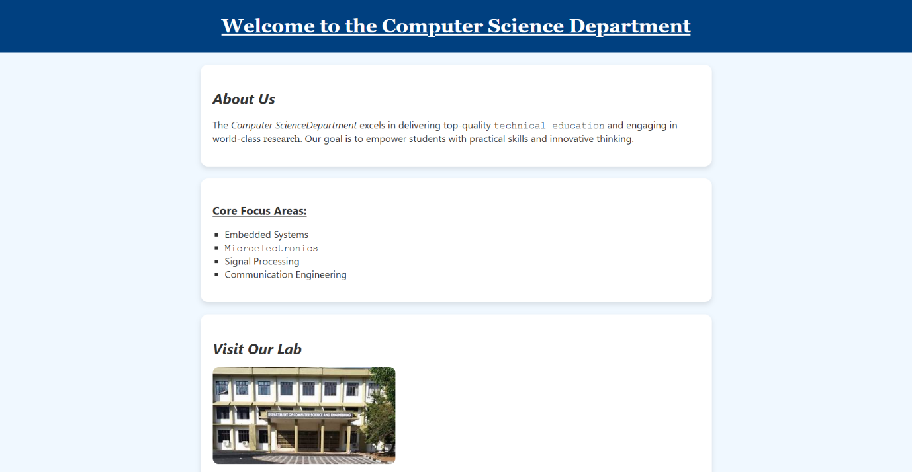Output :-

